**‘For nine years I couldn’t speak – then I found my voice’**

JULY 8, 2018

**For the first nine years of his life, Jonathan Bryan was locked inside his own mind. Then he found a way to communicate – and what he has to say is extraordinary…**

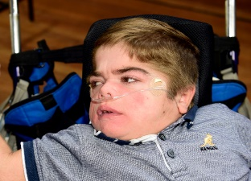Jonathan Bryan (Photo by Paul Doyle)

Can you imagine not being able to speak or communicate? The silence, the loneliness, the pain. Inside you disappear to magical places, but most of the time remain imprisoned within the isolation. Waiting. Longing. Hoping. Until someone realises your potential and discovers your key. Now you are free, flying like a wild bird in the open sky. A voice for the voiceless. This is my story.

I spent the first part of my childhood unable to tell my story. In silence I lived behind the labels attached to my dysfunctional body. Severe cerebral palsy. Profound and multiple learning difficulties. Nonverbal. Chronic lung disease. Curved spine. Transplanted kidney. Even my teeth have a disability.

For years these labels defined me. Expectations founded on my appearance. Silence suffocated my identity – my very being sealed shut; with my passions, dislikes and sharp mind deadened in the soundless void. I couldn’t even tell you my name.

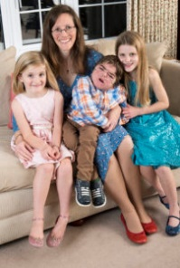Jonathan with his mother Chantal and sisters Jemima (L) & Susannah (R). (Photo: Murray Sanders)

At home my younger sisters, Susannah and Jemima, more than made up for my quietness! Like a moon rotating the earth they are my world, and I delight in them more than anyone else. Together we danced to life’s rhythm, unfettered by the silence; instinctively knowing and being without the need for verbal communication.

Special school was only a short drive away, but so distant from the rest of my world that it might as well have been a foreign country. In the classroom we sat, nine wheelchair islands, isolated from each other. We were arranged in a circle with just the right distance between us so that we couldn’t touch one another (any successful attempts at this precipitated a complete readjustment to ensure it didn’t happen again. I have no idea why).

At eight years old I was the youngest in the class, which was predominantly made up of teenagers. We were parked in front of a television – nursery rhymes with basic animation and presenters that my two-year-old sister Jemima would have been happy to watch. One day I was positioned next to my best friend Will who squealed in pure delight. His stiff limbs rose towards me like a swan spreading its wings preparing for flight. Looking into his piercing blue eyes we connected at a level beyond words. Together we travelled the landscapes of our imaginations; outwardly vacant, inwardly amusing ourselves, until our journey was abruptly interrupted. ‘Jonathan! Are you here?’ The teacher’s sing-song soft high voice, pitched at a baby’s understanding, grated on my inner eight-year-old being.

In the classroom our wasted school hours, weeks and years suffocated expectation with mindless activity. While I sat through ‘reading’ (which meant being subjected to Farmer Duck, the same preschool storybook we had the previous week), ‘art’ (having my hand painted and stamped on to a piece of paper) and ‘golden time’ (lying in a semi-darkened room watching lights on the ceiling while listening to yet more nursery rhymes), I dreamt of my invaluable education at home the next morning, with Mummy and my home education teacher Sarah.

For as long as I could remember, Mummy had read to me: Bible stories, funny stories, short stories. For days, weeks and months we had curled up in a hospital bed together and plunged ourselves into a novel. Books have nourished my mind and prevented mental decay during my years of silence. Trapped in cerebral palsy I run within the pages: skipping, laughing, exploring. I have inhabited the scenes of authors’ pictures and woven them with my imagination. Words have been my portal into another world. And now the mantle was passing on to me.

*“WORDS HAVE BEEN MY PORTAL INTO ANOTHER WORLD”*

Picking up the spelling board, Sarah’s finger pointed to where my eyes were looking. An eye-gaze machine had not helped because of my astigmatism and medications, and a specialist had introduced a spelling board. To select a letter, I needed to move my eyes across the board. Following my lead, we slow-waltzed around the board, synchronised to the music of the word in my head. I spelt out an ‘m’ and then a ‘y’. Because the process was so tiring and because I wanted to draw out the suspense, I closed my eyes. After the usual cajoling to open them, I started to enjoy the ensuing conversation.

‘Did he put a space after the “y”?’ Mummy needed to know as she was typing what I wrote into the computer.‘ He hasn’t yet, but I expect he will when he opens up again. I can’t think what else he would want to write beginning “my”.’ Sarah obviously had no idea of the word I was creating. I opened up ready for play to recommence.

‘My’…‘r’…‘i’…‘a’…‘d’…‘s’…’ Mummy articulated each letter but Sarah was so engrossed in mirroring my eyes with her finger she had lost the word. ‘Myriads.’ Mummy looked at Sarah, who stared back at her, stunned.

Their silence heralded the end of mine.

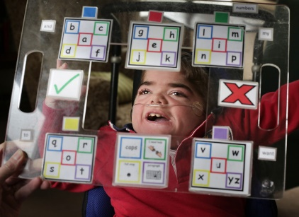Jonathan Bryan (Photo by Tom Pilston)

At last I could tell my family about my time in the garden. This was my one early memory that Mummy knew nothing about. For nine years she had shared every aspect of my life; whenever I was admitted to hospital she effectively became an inpatient with me, only leaving our bed to get food. At home, when I wanted to play, she sat behind me supporting my body and helping my hands to manipulate the toys. If I was tired, she read to me; if I was excited, we played instruments; if we needed some fresh air, she took me into the garden for a walk. But I had also visited the garden on my own in my mind.

It was when I was in intensive care, in an induced coma. While my body hung in the balance, I was tasting what it was like on the other side. I had never felt so alive. Free from my crippled, dysfunctional body, I ran. Ran! Fresh grass lay beneath my supple feet. A warm soft breeze caressed my face. Sounds of children’s laughter mingled with birdsong.

For the first time I could see clearly. The murkiness had been blown away to reveal abundant meadows of spring flowers swaying their heads under the mellow sunlight. As I stretched my body to its full height (my scoliosis had elongated and vanished altogether), I relished the fact that this dragon had been banished. All my life this monster had subjugated my body to painful spasms, distorting and writhing my frame, breathing fire under my skin, stealing my voice; and now it was dead and defeated for ever! Swinging my free arms, I sauntered through an orchard. Savouring every moment, enjoying the harmony between my perfect new body and my soul. I was whole.

And that’s when I saw him: Noah, my beautiful friend who had died the year before from a brain tumour. Capturing in words those moments of reunion is so hard, but as the time drew on I was aware that I had a choice to make. Either I could stay to meet the gardener, my saviour; or I could go back to my fragile sick body; back to my mind trapped in silence; back to the family I loved.

‘Jonathan.’ My mother’s voice called me from beyond the garden, and my decision was made. That was the hardest decision of my life, but it has also shaped my perspective ever since. While my soul longs to live in the garden, my heart is torn between my family and freedom, but with Jesus’s presence helping me here, I know I can endure my limiting body for longer. My experience in the garden has given me a zest for life.

I was allowed to spend an afternoon a week at the local primary school when I was four. Before, it didn’t matter what lessons I joined my peers for as the main purpose was social interaction with other children my own age. However, now I could communicate well, Mummy and Daddy asked them to consider increasing my time there to two afternoons a week. And they said yes! Not only that, but the teacher moved sessions around so that I could attend the more academic ones.

If only we felt the same level of jubilation at my special school. Instead everything continued in much the same way as it had always done. Most frustratingly of all, it seemed to us that nobody – except the one-to-one teaching assistant assigned to me – believed that I could spell using the alphabet board. When I looked at my friend Will, my heart was filled with deep sadness. I had moved into a league of my own and it was lonely watching the isolation of my friends, who had no independent way to communicate, mostly relying on facial expressions. The key for children like me is to find out what we can independently control and then use this as a way to access the curriculum. I never had profound and multiple learning difficulties, but I did have profound and multiple difficulties in accessing learning.

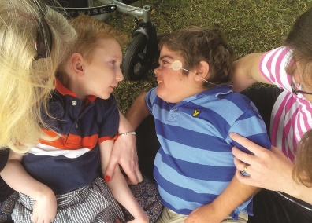Jonathan with his friend Will at the park.

While the special school never seemed to believe me, the local village primary school embraced my new way to communicate, never doubting my abilities, and they translated this into a place on their register. They took my desire to learn as seriously as they had previously taken my need for social interaction. Being at a mainstream primary school gave me the literary tools I needed, introducing me to different genres and techniques so that my creative writing could flourish. I didn’t miss out on the fun either. Orienteering, archery, shooting, fencing, canoeing, climbing – every activity my friends did, I joined them for, not as an onlooker but as a participant! For the first time I could feel the breeze in my hair as I sat on Mummy’s lap whizzing downhill on an adapted electric bike, the achievement of hitting a bull’s-eye and the exhilarating terror of being hoisted to the top of the climbing wall.

In the end I requested a meeting with the head teacher to explain that I wasn’t coming back to special school. Abandoning Will was heartbreaking, but thankfully we could still meet up at the local coffee shop or park where we could sit together, revelling in each other’s companionship. Last week he came to visit and Mummy asked him if he would like to try using my spelling board. Will looked at the board as Mummy sounded out the vowel he had chosen. Having spent the past two and a half years watching me use the spelling board, Will was decisive in his choice, but now he paused, uncertain.

Then Mummy offered: ‘Could it be “I”?’ At which point Will continued with ‘don’t want to go home’. Thus I witnessed Will’s first free conversation with the board: his first words, his first ‘I love you’ to his mother, aged 13.

If my mother hadn’t removed me from special school for a few hours a day to teach me how to read and write I would not be able to write this for you today. For a nonverbal child, learning to read and write is not just a life skill. It unlocks our voice. It gives us life in all its fullness.

*In 2016, at the age of ten, Jonathan began a campaign ‘Teach Us Too’, calling for all disabled children to be taught to read and write regardless of their label. He wrote to MPs and the media and launched a petition which has nearly 250,000 signatures. In 2017, he gave a speech at the House of Lords and received a Diana Legacy Award from Prince William and Prince Harry.*

*This is an edited extract from ‘Eye Can Write – A Memoir of a Child’s Silent Soul Emerging’ by Jonathan Bryan, which will be published by Lagom, price £12.99*